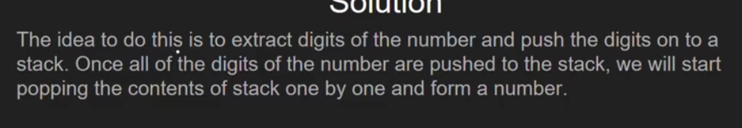
Reverse a number using stack
Eg: 3456
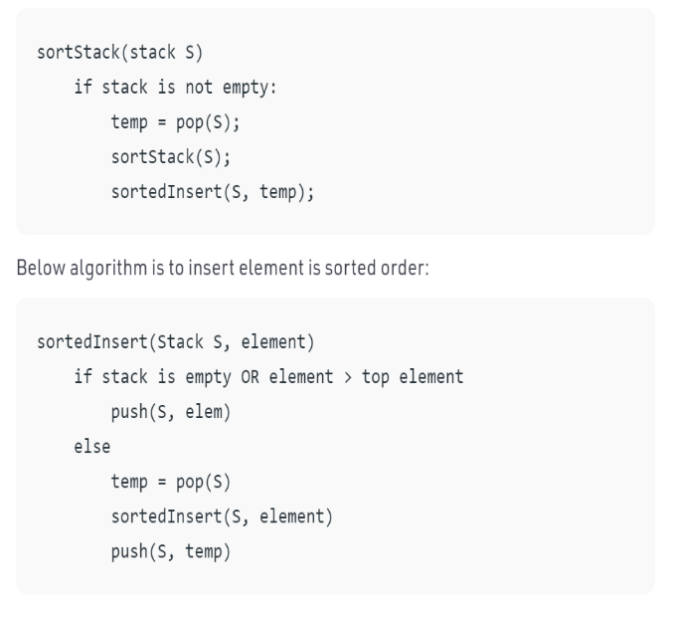
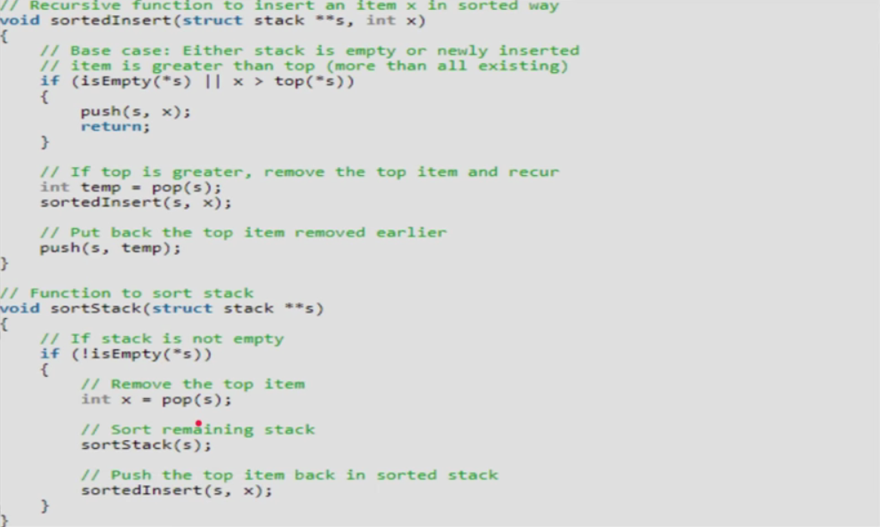
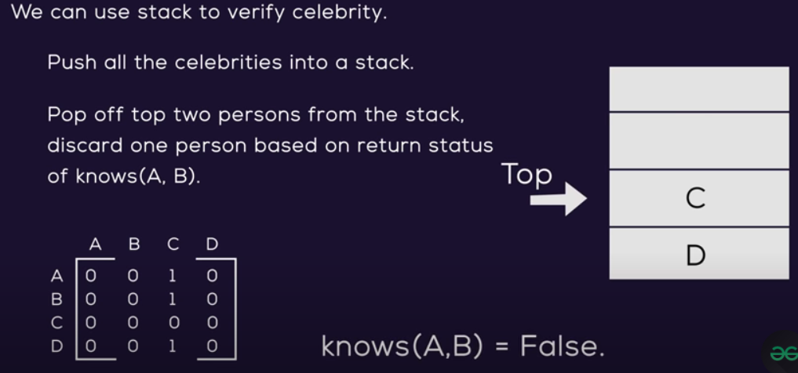
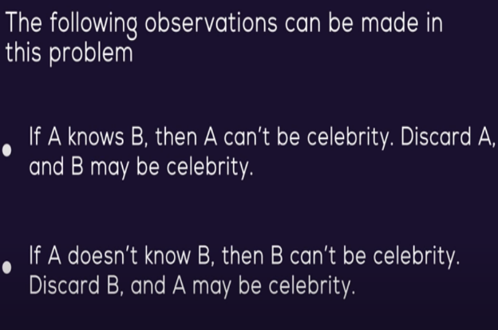
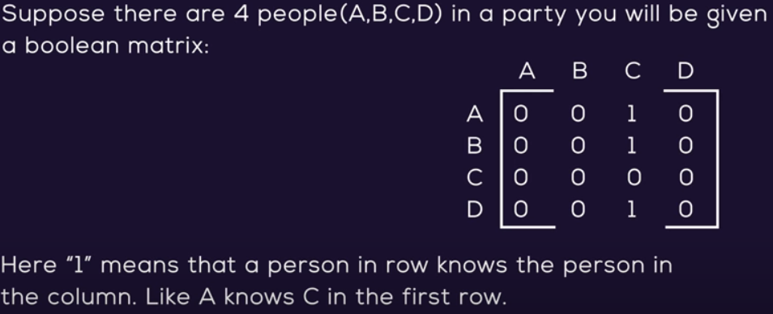
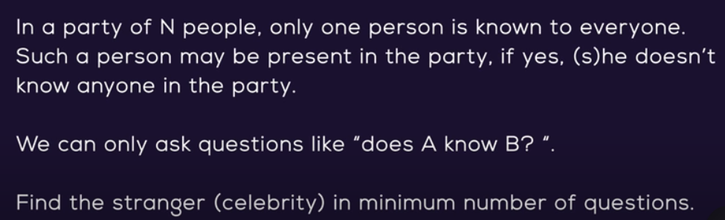
6543
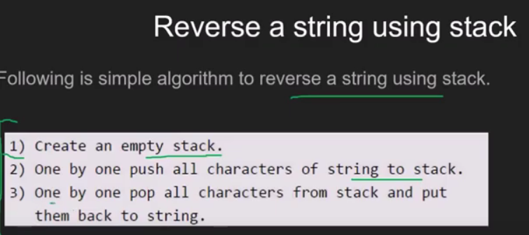
Sort stack using recursion idea of the solution is to hold all values in Function Call Stack until the stack becomes empty. When the stack becomes empty, insert all held items one by one in sorted order. Here sorted order is important.

